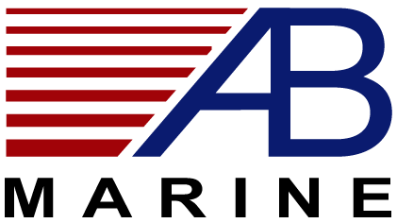

AUTOPROP CUSTOM TOOLS - FOR REMOVAL/REPAIR

List Pricing 2013

 | Part Number | Description | MSRP
#1 | Prop Puller – H5/H6 | Prop Removal tool | $232.00
#2 | Prop Puller – H9 | Prop Removal tool | $349.00
#3 | TRI-0197H5 | H5 RB Nut Spanner | $188.50
#4 | TRI-0197H6 | H6 RB Nut Spanner | $188.50
#5 | TRI-0167H9 | H9 RB Nut Spanner | $188.50
#6 | TRI-0224 | H5 RB Lock Tab Screw Spanner | $97.00
#7 | TRI-0227 | H6 RB Lock Tab Screw Spanner | $97.00
#8 | TRI-0168/Peg Spanner | H5/H6 Bearing Retaining cap removal spanner | $77.50
#9 | TRI-0175 | Grease Nipple - for Roller Bearing type only | $29.65
#10 | Sta-Lube 3110 CRC | Tube of Grease – 14oz Lithium Complex type | $14.80

1/1/2013

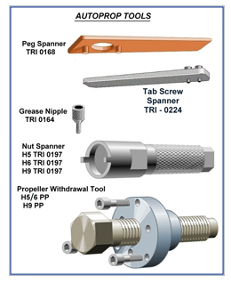

- Prices subject to change without notice
- Prices are FOB Newport, RI

